NUCL 510 HMWK 1

1. ENDF/B-VII.0 Library
   1. Sub Libraries

|  |  |
| --- | --- |
| Sub-Library Description | # of Materials |
| Neutron Reaction | 393 |
| Thermal Neutron Scattering | 20 |
| Neutron Cross Sections Standards | 8 |
| Photonuclear Reaction | 163 |
| Proton Reaction | 48 |
| Deuteron Reaction | 5 |
| Triton Reaction | 3 |
| 3He Reaction | 2 |
| Decay Data | 3838 |
| Neutron induced Fission Yields | 31 |
| Spontaneous Fission Yields | 9 |
| Photo Atomic | 100 |
| Atomic Relaxation | 100 |
| Electro-Atomic | 100 |

* 1. Isomers and Elements
     1. Isomers – 95-Am-244M, 95-Am-242M, 67-Ho-166M, 61-Pm-148M, 52-Te-129M, 52-Te-127M, 48-Cd-115M, 47-Ag-110M, 27-Co-58M
     2. Elements – 6-C-0, 23-V-0, 30-Zn-0 {because there are more than three elements that occur naturally (1-H-1, 2-He-4, 3-Li-7, 5-Bo-11, …) I am assuming elements are denoted in this list by atomic mass of 0}
  2. Target Materials for Proton Reactions, Light Ions…
     1. Proton

|  |  |
| --- | --- |
| ------- | --------- |
| # | Material |
| ------- | --------- |
| 1) | 1-H - 1 |
| 2) | 1-H - 2 |
| 3) | 1-H - 3 |
| 4) | 2-He- 3 |
| 5) | 3-Li- 6 |
| 6) | 3-Li- 7 |
| 7) | 4-Be- 9 |
| 8) | 5-B - 10 |
| 9) | 6-C - 12 |
| 10) | 6-C - 13 |
| 11) | 7-N - 14 |
| 12) | 8-O - 16 |
| 13) | 13-Al- 27 |
| 14) | 14-Si- 28 |
| 15) | 14-Si- 29 |
| 16) | 14-Si- 30 |
| 17) | 15-P - 31 |
| 18) | 20-Ca- 40 |
| 19) | 24-Cr- 50 |
| 20) | 24-Cr- 52 |
| 21) | 24-Cr- 53 |
| 22) | 24-Cr- 54 |
| 23) | 26-Fe- 54 |
| 24) | 26-Fe- 56 |
| 25) | 26-Fe- 57 |
| 26) | 28-Ni- 58 |
| 27) | 28-Ni- 60 |
| 28) | 28-Ni- 61 |
| 29) | 28-Ni- 62 |
| 30) | 28-Ni- 64 |
| 31) | 29-Cu- 63 |
| 32) | 29-Cu- 65 |
| 33) | 41-Nb- 93 |
| 34) | 74-W -182 |
| 35) | 74-W -183 |
| 36) | 74-W -184 |
| 37) | 74-W -186 |
| 38) | 80-Hg-196 |
| 39) | 80-Hg-198 |
| 40) | 80-Hg-199 |
| 41) | 80-Hg-200 |
| 42) | 80-Hg-201 |
| 43) | 80-Hg-202 |
| 44) | 80-Hg-204 |
| 45) | 82-Pb-206 |
| 46) | 82-Pb-207 |
| 47) | 82-Pb-208 |
| 48) | 83-Bi-209 |

* + 1. Photonuclear

|  |  |
| --- | --- |
| ------- | ---------- |
| # | Material |
| ------- | ---------- |
| 1) | 1-H - 2 |
| 2) | 4-Be- 9 |
| 3) | 6-C - 12 |
| 4) | 6-C - 13 |
| 5) | 7-N - 14 |
| 6) | 7-N - 15 |
| 7) | 8-O - 16 |
| 8) | 8-O - 17 |
| 9) | 8-O - 18 |
| 10) | 11-Na- 23 |
| 11) | 12-Mg- 24 |
| 12) | 12-Mg- 25 |
| 13) | 12-Mg- 26 |
| 14) | 13-Al- 27 |
| 15) | 14-Si- 28 |
| 16) | 14-Si- 29 |
| 17) | 14-Si- 30 |
| 18) | 16-S - 32 |
| 19) | 16-S - 33 |
| 20) | 16-S - 34 |
| 21) | 16-S - 36 |
| 22) | 17-Cl- 35 |
| 23) | 17-Cl- 37 |
| 24) | 18-Ar- 36 |
| 25) | 18-Ar- 38 |
| 26) | 18-Ar- 40 |
| 27) | 20-Ca- 40 |
| 28) | 20-Ca- 42 |
| 29) | 20-Ca- 43 |
| 30) | 20-Ca- 44 |
| 31) | 20-Ca- 46 |
| 32) | 20-Ca- 48 |
| 33) | 22-Ti- 46 |
| 34) | 22-Ti- 47 |
| 35) | 22-Ti- 48 |
| 36) | 22-Ti- 49 |
| 37) | 22-Ti- 50 |
| 38) | 23-V - 51 |
| 39) | 24-Cr- 50 |
| 40) | 24-Cr- 52 |
| 41) | 24-Cr- 53 |
| 42) | 24-Cr- 54 |
| 43) | 25-Mn- 55 |
| 44) | 26-Fe- 54 |
| 45) | 26-Fe- 56 |
| 46) | 26-Fe- 57 |
| 47) | 26-Fe- 58 |
| 48) | 27-Co- 59 |
| 49) | 28-Ni- 58 |
| 50) | 28-Ni- 60 |
| 51) | 28-Ni- 61 |
| 52) | 28-Ni- 62 |
| 53) | 28-Ni- 64 |
| 54) | 29-Cu- 63 |
| 55) | 29-Cu- 65 |
| 56) | 30-Zn- 64 |
| 57) | 30-Zn- 66 |
| 58) | 30-Zn- 67 |
| 59) | 30-Zn- 68 |
| 60) | 30-Zn- 70 |
| 61) | 32-Ge- 70 |
| 62) | 32-Ge- 72 |
| 63) | 32-Ge- 73 |
| 64) | 32-Ge- 74 |
| 65) | 32-Ge- 76 |
| 66) | 38-Sr- 84 |
| 67) | 38-Sr- 86 |
| 68) | 38-Sr- 87 |
| 69) | 38-Sr- 88 |
| 70) | 38-Sr- 90 |
| 71) | 40-Zr- 90 |
| 72) | 40-Zr- 91 |
| 73) | 40-Zr- 92 |
| 74) | 40-Zr- 93 |
| 75) | 40-Zr- 94 |
| 76) | 40-Zr- 96 |
| 77) | 41-Nb- 93 |
| 78) | 41-Nb- 94 |
| 79) | 42-Mo- 92 |
| 80) | 42-Mo- 94 |
| 81) | 42-Mo- 95 |
| 82) | 42-Mo- 96 |
| 83) | 42-Mo- 97 |
| 84) | 42-Mo- 98 |
| 85) | 42-Mo-100 |
| 86) | 46-Pd-102 |
| 87) | 46-Pd-104 |
| 88) | 46-Pd-105 |
| 89) | 46-Pd-106 |
| 90) | 46-Pd-107 |
| 91) | 46-Pd-108 |
| 92) | 46-Pd-110 |
| 93) | 47-Ag-107 |
| 94) | 47-Ag-108 |
| 95) | 47-Ag-109 |
| 96) | 48-Cd-106 |
| 97) | 48-Cd-108 |
| 98) | 48-Cd-110 |
| 99) | 48-Cd-111 |
| 100) | 48-Cd-112 |
| 101) | 48-Cd-113 |
| 102) | 48-Cd-114 |
| 103) | 48-Cd-116 |
| 104) | 50-Sn-112 |
| 105) | 50-Sn-114 |
| 106) | 50-Sn-115 |
| 107) | 50-Sn-116 |
| 108) | 50-Sn-117 |
| 109) | 50-Sn-118 |
| 110) | 50-Sn-119 |
| 111) | 50-Sn-120 |
| 112) | 50-Sn-122 |
| 113) | 50-Sn-124 |
| 114) | 51-Sb-121 |
| 115) | 51-Sb-123 |
| 116) | 52-Te-120 |
| 117) | 52-Te-122 |
| 118) | 52-Te-123 |
| 119) | 52-Te-124 |
| 120) | 52-Te-125 |
| 121) | 52-Te-126 |
| 122) | 52-Te-128 |
| 123) | 52-Te-130 |
| 124) | 53-I -127 |
| 125) | 53-I -129 |
| 126) | 55-Cs-133 |
| 127) | 55-Cs-135 |
| 128) | 55-Cs-137 |
| 129) | 59-Pr-141 |
| 130) | 62-Sm-144 |
| 131) | 62-Sm-147 |
| 132) | 62-Sm-148 |
| 133) | 62-Sm-149 |
| 134) | 62-Sm-150 |
| 135) | 62-Sm-151 |
| 136) | 62-Sm-152 |
| 137) | 62-Sm-154 |
| 138) | 65-Tb-158 |
| 139) | 65-Tb-159 |
| 140) | 67-Ho-165 |
| 141) | 73-Ta-181 |
| 142) | 74-W -180 |
| 143) | 74-W -182 |
| 144) | 74-W -183 |
| 145) | 74-W -184 |
| 146) | 74-W -186 |
| 147) | 79-Au-197 |
| 148) | 82-Pb-206 |
| 149) | 82-Pb-207 |
| 150) | 82-Pb-208 |
| 151) | 83-Bi-209 |
| 152) | 90-Th-232 |
| 153) | 92-U -233 |
| 154) | 92-U -234 |
| 155) | 92-U -235 |
| 156) | 92-U -236 |
| 157) | 92-U -238 |
| 158) | 93-Np-237 |
| 159) | 94-Pu-238 |
| 160) | 94-Pu-239 |
| 161) | 94-Pu-240 |
| 162) | 94-Pu-241 |
| 163) | 95-Am-241 |

* + 1. Thermal Neutron Scattering

|  |  |
| --- | --- |
| ------- | ---------- |
| # | Material |
| ------- | ---------- |
| 1) | H(H2O) |
| 2) | para-H |
| 3) | ortho-H |
| 4) | H(ZrH) |
| 5) | D(D2O) |
| 6) | para-d |
| 7) | ortho-d |
| 8) | Be metal |
| 9) | Be(BeO) |
| 10) | O(BeO) |
| 11) | graphite |
| 12) | l-ch4 |
| 13) | s-ch4 |
| 14) | H(CH2) |
| 15) | BENZINE |
| 16) | 13-Al- 27 |
| 17) | 26-Fe- 56 |
| 18) | Zr(ZrH) |
| 19) | O(UO2) |
| 20) | U(UO2) |
| ------- | ---------- |

* + 1. Light Ion

|  |  |
| --- | --- |
| ------- | ---------- |
| # | Material |
| ------- | ---------- |
| 1) | 1-H - 2 |
| 2) | 1-H - 3 |
| 3) | 2-He- 3 |
| 4) | 3-Li- 6 |
| 5) | 3-Li- 7 |
| 1) | 1-H - 3 |
| 2) | 2-He- 3 |
| 3) | 3-Li- 6 |
| 1) | 2-He- 3 |
| 2) | 3-Li- 6 |

* 1. MT Numbers
     1. total – MT #1
     2. Elastic Scattering – MT #2
     3. Total Inelastic Scattering – MT #3
     4. Capture – MT #102
     5. Total Fission – MT #18
     6. (n,n1) Inelastic Scattering – MT #4
     7. Total nu bar – MT #452
     8. Prompt nu bar – MT #456
     9. Delayed nu bar – MT #455
     10. (n,2n) – MT #16
     11. (n,3n) – MT #17
     12. (n, alpha) – MT #107
  2. MF Numbers
     1. MF #1 – General Information
     2. MF #2 – Resonance Parameter Data
     3. MF #3 – Reaction Cross Sections
     4. MF #4 – Angular Distributions for Emitted Particles
     5. MF #5 – Energy Distributions for Emitted Particles
     6. MF #6 – Energy-Angle Distributions for Emitted Particles
     7. MF #7 – Thermal Neutron Scattering Law Data
     8. MF #8 – Radioactivity and Fission-Product Yield Data

1. Cross Section Plotting
   1. Fission: U-235 (Blue), U-238 (Red), Pu-239 (Green)

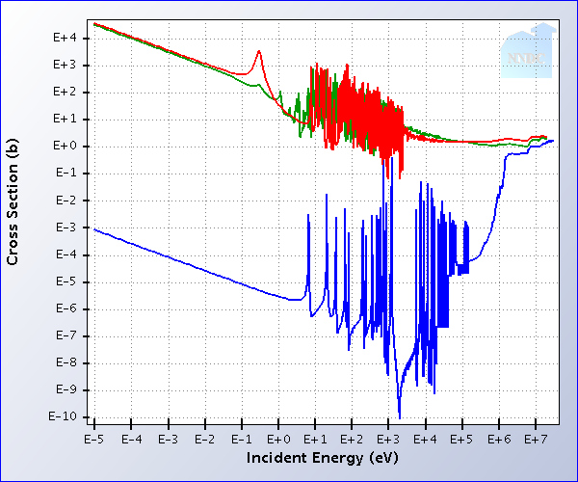

* 1. Elastic Scattering: U-235 (Blue), U-238 (Red), Pu-239 (Green)

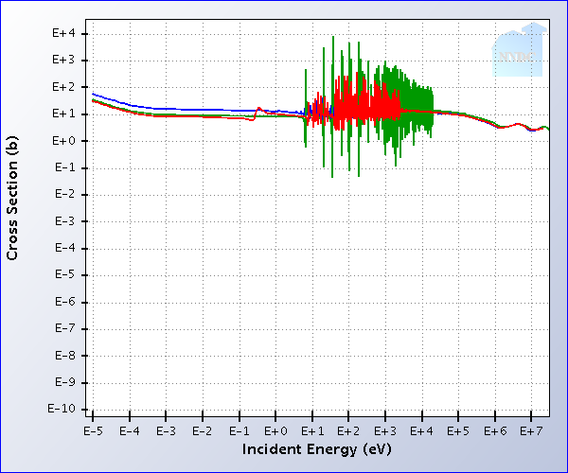

* 1. Total Inelastic Scattering: U-235 (Blue), U-238 (Red), Pu-239 (Green)

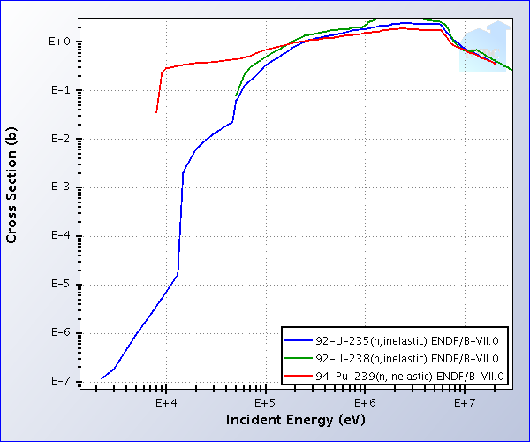

* 1. Elastic Scattering: H-1, H-2, C-12, Be-9

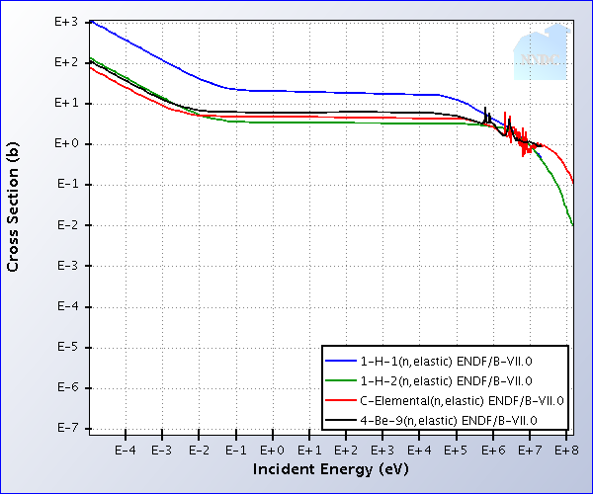

* 1. Elastic Scattering: Na-23, Fe-56, Pb-208

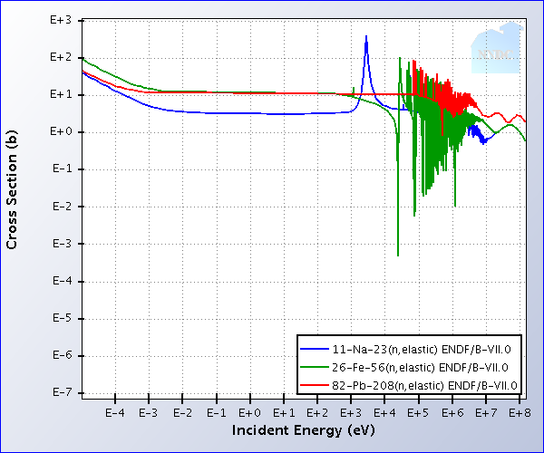

* 1. Capture: B-10, Gd-154

